Experiment No 4
Roll No:24141030 Lab: PL-II

Theory

1. Introduction to Lists
A list is an ordered, mutable (changeable) collection of elements enclosed in square brackets []. Lists are one of the most versatile and commonly used data structures in Python because they can contain elements of different data types.
Example:
mixed_list = [10, "Hello", 3.14, True, [1, 2, 3]]

2. Characteristics of Lists
Property | Description
Ordered | Elements maintain their insertion order
Mutable | Can be modified after creation
Heterogeneous | Can contain different data types
Indexable | Access elements using index (0-based)
Iterable | Can loop through elements
Dynamic | Can grow or shrink in size

3. Creating Lists
Method | Example
Empty list | my_list = []
With elements | my_list = [1, 2, 3]
Using list() constructor | my_list = list((1, 2, 3))
List comprehension | my_list = [x**2 for x in range(5)]

4. List Indexing and Slicing
Similar to strings, lists support indexing and slicing.
Example:
lst = [10, 20, 30, 40, 50]
print(lst[0]) # 10
print(lst[-1]) # 50
print(lst[1:4]) # [20, 30, 40]
print(lst[::2]) # [10, 30, 50]
print(lst[::-1]) # [50, 40, 30, 20, 10]

5. List Methods
Method | Description | Example
append(x) | Adds x at end | lst.append(4)
insert(i, x) | Inserts x at index i | lst.insert(1, 5)
extend(iterable) | Adds all elements from iterable | lst.extend([6,7])
remove(x) | Removes first occurrence of x | lst.remove(3)
pop(i) | Removes and returns element at i | lst.pop(2)
clear() | Removes all elements | lst.clear()
index(x) | Returns index of first x | lst.index(5)
count(x) | Counts occurrences of x | lst.count(2)
sort() | Sorts list in place | lst.sort()
reverse() | Reverses list in place | lst.reverse()
copy() | Returns shallow copy | lst2 = lst.copy()

6. List Operations
Operation | Description | Example
+ | Concatenation | [1,2] + [3,4] → [1,2,3,4]
* | Repetition | [1,2] * 3 → [1,2,1,2,1,2]
in | Membership | 2 in [1,2,3] → True
not in | Non-membership | 5 not in [1,2,3] → True

7. List Comprehension
List comprehension provides a concise way to create lists.
Syntax: [expression for item in iterable if condition]
Examples:
squares = [x**2 for x in range(5)] # [0,1,4,9,16]
evens = [x for x in range(10) if x%2==0] # [0,2,4,6,8]
matrix = [[j for j in range(3)] for i in range(3)] # 2D list

Programs and Code:

1. Program to create and display a list
my_list = [10, 20, 30, 40, 50]
print("List:", my_list)
print("First element:", my_list[0])
print("Last element:", my_list[-1])
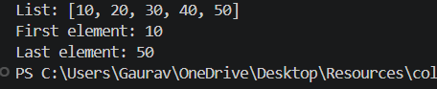

2. Program to find sum and average of list elements
numbers = [int(x) for x in input("Enter numbers separated by space: ").split()]
total = sum(numbers)
average = total / len(numbers)
print(f"Sum: {total}")
print(f"Average: {average}")
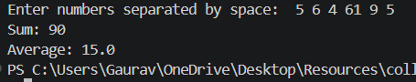
3. Program to find maximum and minimum element in a list
numbers = [int(x) for x in input("Enter numbers separated by space: ").split()]
print(f"Maximum: {max(numbers)}")
print(f"Minimum: {min(numbers)}")
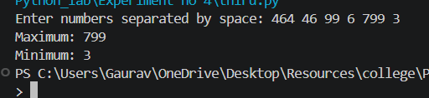
4. Program to sort elements of a list
numbers = [int(x) for x in input("Enter numbers separated by space: ").split()]
numbers.sort()
print(f"Ascending order: {numbers}")
numbers.sort(reverse=True)
print(f"Descending order: {numbers}")
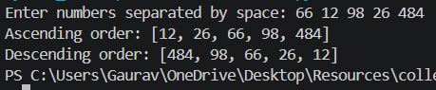
5. Program to remove duplicate elements from a list
numbers = [int(x) for x in input("Enter numbers separated by space: ").split()]
unique = []
for num in numbers:
if num not in unique:
unique.append(num)
print(f"List after removing duplicates: {unique}")
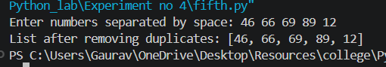
6. Program to search an element in a list
numbers = [int(x) for x in input("Enter numbers separated by space: ").split()]
search = int(input("Enter element to search: "))
if search in numbers:
print(f"Element {search} found at index {numbers.index(search)}")
else:
print(f"Element {search} not found")
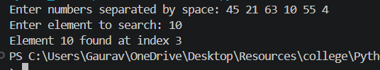
7. Program to merge two lists
list1 = [int(x) for x in input("Enter first list: ").split()]
list2 = [int(x) for x in input("Enter second list: ").split()]
merged = list1 + list2
print(f"Merged list: {merged}")
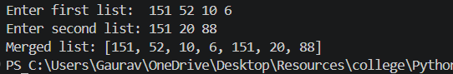
8. Program to count even and odd numbers in a list
numbers = [int(x) for x in input("Enter numbers separated by space: ").split()]
even = sum(1 for n in numbers if n % 2 == 0)
odd = len(numbers) - even
print(f"Even numbers: {even}")
print(f"Odd numbers: {odd}")
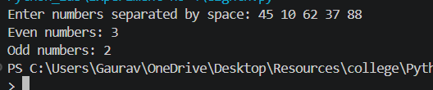
9. Program to find second largest element in a list
numbers = [int(x) for x in input("Enter numbers separated by space: ").split()]
unique = list(set(numbers))
unique.sort()
if len(unique) >= 2:
print(f"Second largest: {unique[-2]}")
else:
print("Not enough unique elements")
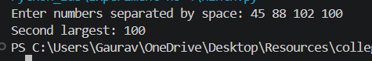
10. Program to demonstrate list slicing
lst = [0, 1, 2, 3, 4, 5, 6, 7, 8, 9]
print("Original list:", lst)
print("Elements 2 to 5:", lst[2:6])
print("First 3 elements:", lst[:3])
print("Last 3 elements:", lst[-3:])
print("Every 2nd element:", lst[::2])
print("Reversed list:", lst[::-1])
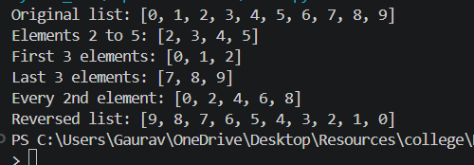

Conclusion
In this experiment, we studied list data structure in Python including creation, sum/average calculation, min/max finding, sorting, duplicate removal, searching, merging, counting even/odd, finding second largest, and list slicing. Lists are versatile, mutable data structures essential for storing and manipulating collections of data.

